Database Design Document

VerifyAI: AI Fact Checker / Image Authenticator

1. Database Design Objective
The purpose of this database design is to define how VerifyAI stores, organizes, and manages data efficiently. For context, VerifyAI is a fake news detector/fact checker app that aims to allow a user to input a URL, image, or text submission for credibility analysis. The database supports user registration, URL/image/text submissions, AI analysis results, credibility scoring, and storing user history. The design ensures minimal data duplication, clearly defined relationships, efficient performance, scalability, and referential integrity using Primary Keys and Foreign Keys.

2. Entities (Derived from FRD)
- User
- Submission
- URL_Submission
- Image_Submission
- Text_Submission
- Analysis_Run

3. Entity Attributes with Primary Keys (PK) and Foreign Keys (FK)

3.1 User
Purpose: Stores user account information.
- user_id (PK)
- full_name
- email (UNIQUE)
- password_hash
- created_at
- is_deleted (boolean)
- deleted_at (nullable)

3.2 Submission
Purpose: Stores user-submitted content (URL, Image, or Text).
- submission_id (PK)
- user_id (FK → User.user_id)
- submission_type (URL / IMAGE / TEXT)
- created_at

3.3 URL_Submission
Purpose: Stores URL-specific details.
- submission_id (PK, FK → Submission.submission_id)
- url
- domain
- page_title
- fetched_at
Relationship:
- 1:1 with Submission (when submission_type = URL)

3.4 Image_Submission
Purpose: Stores image upload details.
- submission_id (PK, FK → Submission.submission_id)
- image_storage_url (Azure Blob path)
- file_type (jpg / png)
- width
- height
- uploaded_at
Relationship:
- 1:1 with Submission (when submission_type = IMAGE)

3.5 Text_Submission
Purpose: Stores pasted text submissions.
- submission_id (PK, FK → Submission.submission_id)
- input_text
- word_count
- submitted_at
Relationship:
- 1:1 with Submission (when submission_type = TEXT)

3.6 Analysis_Run
Purpose: Stores AI-generated analysis reports.
- analysis_id (PK)
- submission_id (FK → Submission.submission_id)
- status (queued / running / completed / failed)
- model_name
- started_at
- completed_at
- result_label (Fake / Real / Misleading / Unknown)
- credibility_score (0–100)
- ai_generated_score (0–100)
- confidence_score (0–100)
- summary_report
- extracted_content
Relationship:
- 1 Submission → Many Analysis_Runs

4. Relationships Summary

1:N Relationships
- One User → Many Submissions
- One Submission → Many Analysis_Runs

1:1 Relationships
- One Submission → One URL_Submission (if URL type)
- One Submission → One Image_Submission (if Image type)
- One Submission → One Text_Submission (if Text type)

5. ER Diagram
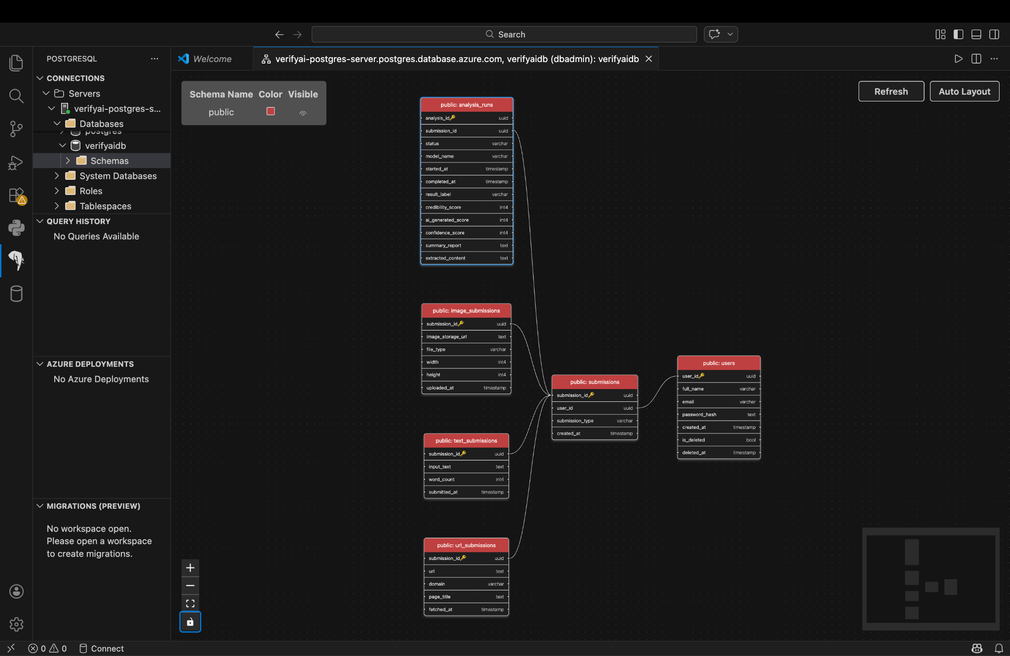
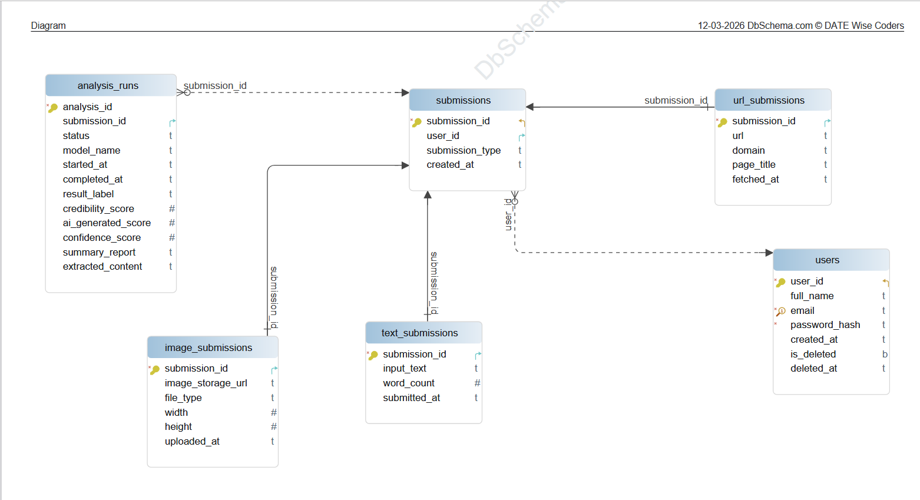
Link: https://drive.google.com/file/d/1jy7msuZ746rzt4wYUlrXKjFnsorYAdC7/view?usp=sharing

6. Justification of Design
This database design supports the core functional requirements of VerifyAI, including user registration, URL/image/text submission, AI credibility scoring, and history tracking. Each submission is stored once and linked directly to its corresponding analysis report. This makes it simple to retrieve previous analyses for display in the user’s history page.
Primary Keys uniquely identify each record, and Foreign Keys maintain referential integrity between related tables. The design is intentionally simplified to ensure it is realistic to implement within the scope of the project while still supporting all required features.

